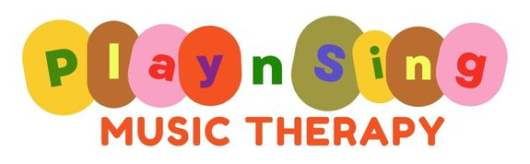
Kathy Butcher - Registered Music Therapist (#667)
17 Prince Street GRAFTON NSW 2460 - PO Box 1500 GRAFTON NSW 2460
0432 804 615 - kathy@playsingmusictherapy.com.au - www.playsingmusictherapy.com.au
@playsingmusictherapygrafton

Parent Self-Referral Form for Music Therapy
Please complete and return to – kathy@playsingmusictherapy.com.au

Your Name:

Email & Phone No:
Date:

Name of child:

Preferred name:

Date of Birth:

Diagnosis (if applicable):

Reason for referral (please note any concerns, goals, other):

National Disability Insurance Scheme (if applicable):
Please note that Play Sing Music Therapy services is usually accessed if you have funding in ‘Improved Daily Living Skills’ section of the plan and is plan or self-managed.
NDIS participant number:

NDIS plan (please attach) or list goals here:

If plan managed: | Company:  Email address for accounts:
Support Coordinator details: | Name:  Organisation:  Phone number:  Email:

