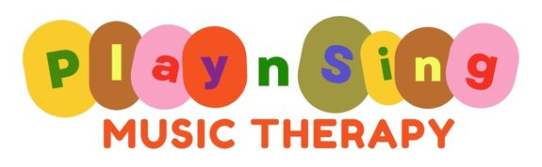
Kathy Butcher - Registered Music Therapist (#667)
17 Prince Street GRAFTON NSW 2460 - PO Box 1500 GRAFTON NSW 2460
0432 804 615 - kathy@playsingmusictherapy.com.au - www.playsingmusictherapy.com.au
@playsingmusictherapygrafton

Music Therapy Referral/Request Form - Organisations
Please complete and return to – kathy@playsingmusictherapy.com.au
Your name:

Organisation details: | Name of organisation:  Phone:  Email:
Date:

Parents name:

Contact Details: | Phone:  Email:

Name of Child:

Date of Birth:

School and year (if applicable):

Diagnosis (if known):

Reason for referral or concerns:

National Disability Insurance Scheme (if applicable):
Please note that Play Sing Music Therapy services is usually accessed if you have funding in ‘Improved Daily Living Skills’ section of the plan and is plan or self-managed
NDIS participant number:

NDIS plan attached or list goals here:

If plan managed: | Company:  Phone number:  Email address for invoices:
Support Coordinator details: | Name:  Organisation:  Phone numbers:  Email:
Any other information?

