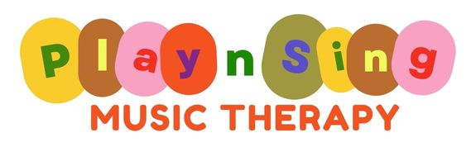
Kathy Butcher - Registered Music Therapist (#667)
17 Prince Street GRAFTON NSW 2460 - PO Box 1500 GRAFTON NSW 2460
0432 804 615 - kathy@playsingmusictherapy.com.au - www.playsingmusictherapy.com.au
@playsingmusictherapygrafton

Music Therapy Referral Request/Intake Form
Please complete and return to – kathy@playsingmusictherapy.com.au
FOR ORGANISATIONS

Name:

Organisation details: | Name of organisation:  Address:  Phone:  Email:
Date of referral:

FOR PARENTS

Name:

Details: | Address:  Phone:  Email:
Date of referral:

Location (please circle)

Music Therapy rooms  I, Level 1, 17 Prince Street Grafton | Other (school etc) address:

Name of child/person:

Preferred name:

Date of Birth:

School and year (if applicable):

Address (if not stated above):

Phone (if not stated above):

Email (if not stated above):

Contact through Messenger (tick if preferred):

Diagnosis (if applicable):

Reason for referral (please note any concerns, goals, other):

Other therapies and contact details:

NDIS Information (if applicable):
NDIS participant number:

Plan dates:

NDIS plan attached or list goals here:

How will accounts be paid (please circle)?  *Please note NDIA managed is not an option to receive music therapy | Plan-managed Self- managed
If plan managed: | Company:  Contact person:  Phone number:  Address:  Email address for accounts:
Support Coordinator details: | Name:  Organisation:  Address:  Phone numbers:  Email:
Any other information?

